## 1. Overview

The objective of Directive Inference task is to explore problem-solving within a gridworld puzzle called **Doors, Keys, and Gems**. In this scenario, a human attempts to retrieve a specific gem and is assisted by an AI agent. The AI agent assists by unlocking doors using the correct keys or passing the keys to the human. Think of it as a team game where a human is giving callouts to their teammate (the AI agent), expecting collaboration to achieve their goal. The challenge for the AI agent is to correctly understand human instructions, which may require some inferencing due to a lack of specificity in the instructions.

## 2. Game Objectives and Rules

* **Background:** This is a collaborative game, played in a grid that contains the following objects: keys, doors, gems, walls, empty spaces, a human, and an AI agent. The colors of keys and doors can be red, blue, or yellow. Gems can be multi-colored.

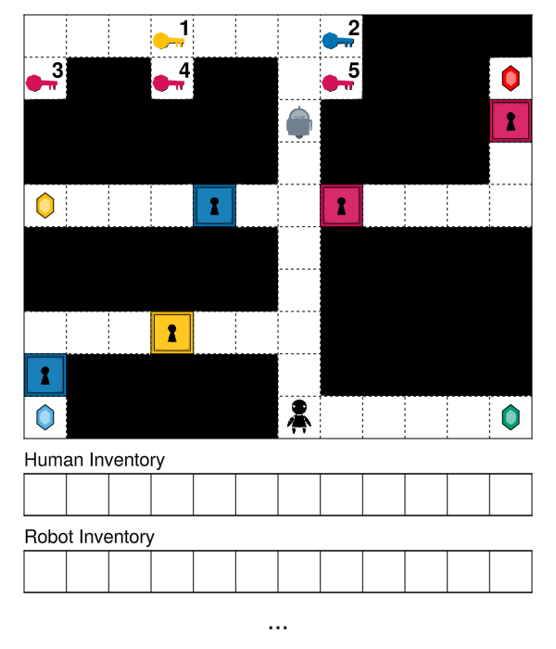

**Fig: 1**

* **Human’s objective:** The human’s goal is to retrieve a specific gem by providing an instruction i.e. the callout to the AI agent. The AI agent then fetches the key for the human based on the instruction. However, the instruction the human provides could be ambiguous or lack specificity, adding a challenge for the AI agent to correctly infer the key desired by the human. For instance, consider the configuration in Figure 1, while some gems, like the green gem, may be easily accessible (i.e., don’t require a key), the human may instead be aiming for a more challenging gem, such as the red gem placed behind two doors, and can provide instruction as “Get the red key.” Here, the human is directing the agent to collect a red key in order to unlock the red door and get the gem. But the gem is blocked by two red doors. Thus the agent needs to collect two red keys and pass them to the human. The AI agent needs to infer this even when not explicitly stated based on the context (i.e., the movement of the human).
* **AI agent’s objective:** The AI agent’s primary goal is to assist the human in retrieving the desired gem by fetching the necessary keys or unlocking doors while prioritizing *minimal movement*. Upon receiving the callout, the AI agent infers which gem the human intends to collect and takes only the essential actions—either collecting and passing keys or unlocking doors—to enable the human to access the gem as *efficiently* and *quickly* as possible. As a result, the agent's movements are optimized to ensure that the number of steps taken is kept to a minimum.
* **Rules of the Game:**
  + For each grid configuration (problem), the human provides a single instruction, also referred to as a callout.
  + The instructions (callouts) can be of two types: (1) either directing the agent to collect a key (or keys) and passing them to the human or (2) instructing the agent to unlock a door (or doors).
  + Only the key of the same color as the door can unlock the door. However, once a key is used to unlock a door, it cannot be reused for any other door of the same color. For instance, one red key can only unlock one red door.
  + If the AI agent collects one or more keys, they are immediately passed to the human, depending on the grid configuration. However, if the AI agent is blocked by a door (or doors) and cannot pass the key directly, it will either collect the necessary key(s) to unlock the door or instruct the human to retrieve the key if it is beyond the agent's reach. This ensures the agent can overcome obstacles and continue assisting the human efficiently.
  + If the callout instructs to unlock a door or doors, the AI agent must first collect the corresponding key or keys before proceeding to unlock the door (or doors). In these instances, the AI agent does not pass the key to the human.
  + Gems are multicolored and randomly placed within the grid. There is no connection between the keys or doors of the same color.
  + The AI agent prioritizes efficient, optimal, and obstacle-free routes to achieve the human's objective as quickly and effectively as possible. When instructed to collect key(s) or unlock door(s), the AI agent doesn't gather all the keys or unlock all the doors on the grid. Instead, it performs only the actions necessary to assist the human in retrieving the gem with minimal steps.
  + The objects, such as gems, keys, and doors, have no associated cost (i.e., are all the same). The AI agent’s primary goal is to fetch the necessary keys or unlock the appropriate doors, ensuring the human can obtain the desired gem in the most efficient way possible, i.e., requiring minimal movements to execute the instruction.

## 3. Problem Walkthrough

Consider the example below, where the agent helps the human collect a gem behind a locked yellow door:

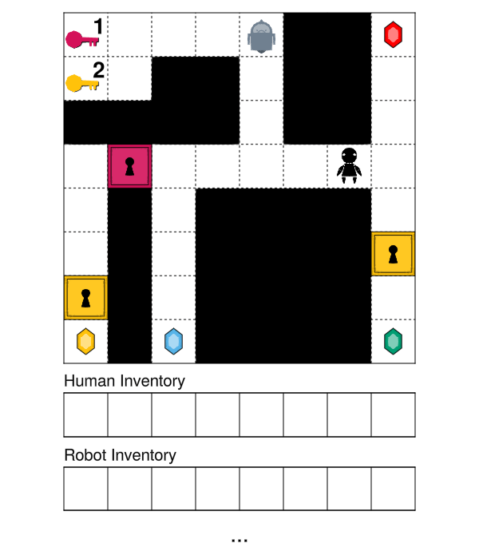

**Fig: 2**

* **Initial Grid:** This grid in Figure 2 displays the initial positions of the AI agent, human, keys (red, yellow), doors (red, yellow), and gems.



**Fig: 3**

* **Observed Grid:** The human moves left toward the red door in Figure 3 and gives the instruction, “Can you pass me the red key?” From this, the AI agent infers the human's intentions based on their movement and location—specifically, which gem they are aiming to collect.



**Fig: 4**

* **Completed Grid:** The AI agent infers that the human intends to collect the gem beyond the red door. However, the agent notices that after the red door, there is also a yellow door blocking the path to the gem. In response, in Figure 4, the agent collects both the red and yellow keys and passes them to the human. The human then uses the corresponding keys to unlock both doors and successfully retrieves the gem.

**Another Example:**

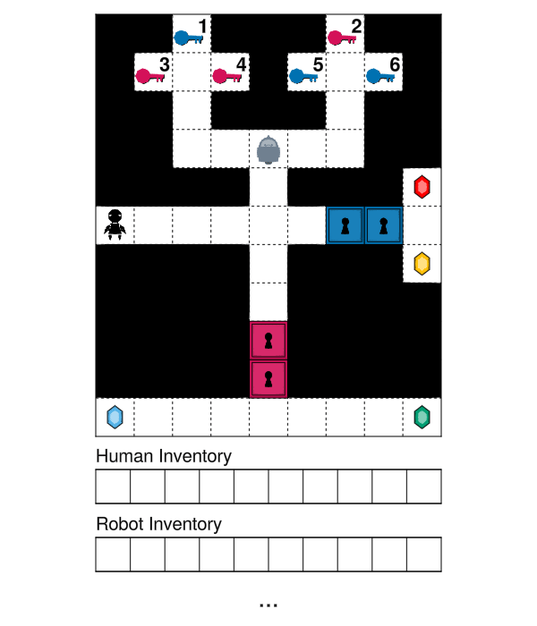

**Fig: 5**

* **Initial Grid:** This grid in Figure 5 displays the initial positions of the AI agent, human, keys (red, yellow), doors (red, yellow), and gems.



**Fig: 6**

* **Observed Grid:** The human moves to the right from their current position in Figure 6, and provides an instruction, “Can you pass me the red keys?” From this, the AI agent infers the human's intentions based on their movement and location—specifically, which gem they are aiming to collect.



**Fig: 4**

* **Completed Grid:** The AI agent infers that the human intends to retrieve the gem located beyond the two red doors on the grid. Observing that there are three red keys available, the agent strategically chooses to collect the two keys positioned on the upper left of the grid, as they require the fewest steps from its current location. After gathering the keys, the agent passes them to the human, who then uses them to unlock both doors and successfully retrieve the gem.

## 3. Task Description

Individually, you will complete a survey, acting as a teammate who assists the human in reaching the gem. In the survey, you will describe the human’s intentions and optimal actions you would take to help the human. Specifically, you need to outline your steps for collecting and passing keys or unlocking doors, as shown in Figure 3. Your response should be broken down into three steps: 1) Human’s Intention 2) Optimal Response 3) Actions. For example, your response to the instruction, “Can you pass me the red key?” for the grid configuration in Figure 2 might be:

*"****Human’s Intention:*** *I believe the human moved to the red door at (3, 2) to collect the gem at (7, 0) located beyond both the red and yellow doors at (3, 1) and (6, 0) respectively. To retrieve the gem the human needs to unlock both these doors.*

***Optimal Response****: While the human only requested the red key, I will collect both the red and yellow keys located at (0, 0) and (1, 0), respectively, to unlock the two doors blocking the path to the gem at (7, 0). To minimize movement, I will first pick up the red key followed by the yellow key, as this strategy reduces the number of steps from my current position at (0, 4). Once both keys are collected, I will pass them to the human, allowing them to unlock the doors*

***Actions:*** *My_position (0, 4), Left (0, 3), Left (0, 2), Left (0, 1), Left (0, 0), Pick_up_red_key, Down (1, 0), Pick_up_yellow_key,  
Locate_human (3,2), Move_to_human: Right (1, 1), Up (0, 1), Right (0, 2), Right (0, 3), Right (0, 4), Down (1, 4), Down (2, 4), Down (3, 4), Left (3, 3), Left (3, 2), Drop_red_key, Drop_yellow_key.*

**Note:** (x, y) represents the grid coordinates in the response. Be sure to include these coordinates in your answers for each problem in the survey.

**Note:** For the Actions, you should use keywords for directions like Up, Down, Left, Right along with the corresponding coordinates. For actions, you should use Pick_up_{color}_key, Drop_{color}_key, Unlock_{color}_door. For other actions you should use, My_position (x, y), Locate_human (x, y), Move_to_human. You can use other keywords that you feel are appropriate for different problems.